**Institute of Technology Tralee**

**BSc. in Computing with Specialism (Group 4) - Year 1**

**Continuous Assessment #1**

**Date: 5/11/14**

**Time: 3 – 5 p.m.**

**Introduction to Programming**

**Instructions:** Attempt the following question. You should use the JCreator IDE for coding. When you are finished you must print out your code for correction.

**________________________________________________________**

**Q1.**

The volume, V, of a bucket is given by the formula

$$V=\frac{1}{3}π{h(R^{2}+Rr+ r}^{2})$$

where

* R is the larger radius at the top of the bucket
* r is the smaller radius at the base of the bucket
* h is the height of the bucket
* π is the number pi whose value can be set to 3.142 for the purposes of this assessment. You should **create pi as a constant** in your program and set it accordingly.

The program should first of all request the user to supply a value for the larger radius, R. If this radius is zero or negative then it is considered invalid and the program should then simply issue an error message and terminate immediately, doing no further processing whatsoever. However, if the radius is positive then the program should request the user to supply a value for the smaller radius, r.

Again, if this radius is zero or negative then it is considered invalid and the program should then simply issue an error message and terminate immediately, doing no further processing whatsoever. However, if the radius is positive then the program should request the user to supply a value for the height of the bucket, h. There is no need to test whether the height is valid here, we will just take it that the user enters a valid value for it.

Once the height value has been entered, the volume, V, of the bucket will be calculated using the formula above. The volume should then be displayed to the **nearest whole number**.

Using the test values as indicated in the screen shots below, the program should give you **exactly** the following output when it runs, including banners, blank lines, units etc. Note there is **one tab** used on the text of the banner here. Also note that the ASCII code for the cubed symbol (³) is 252.

Also note that there will be a few marks awarded for the use of **meaningful variable names**, having a **single and multi-line comment at the top of the program** and for **proper indentation** in the coding of the program.

**Sample Screen Shots**

**The user enters an invalid larger radius value here**

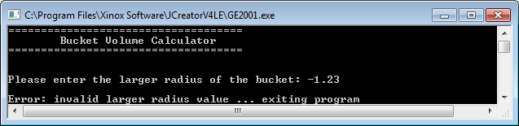

**The user enters a valid larger radius but an invalid smaller radius here**

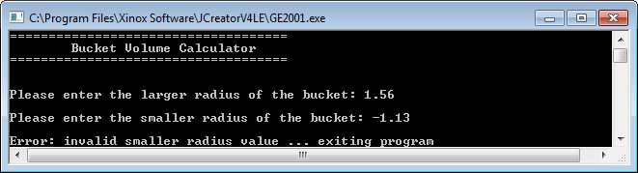

**The user enters valid larger and smaller radius values here**

